1. Where is Hinduism the majority religion?
(a) Nepal (b) Bangladesh (c) Pakistan (d) Sri Lanka

2. Of the following countries, which is most concerned about global warming?
(a) The Maldives (b) Nepal (c) Pakistan (d) Sri Lanka

3. What causes the South Asian monsoon? Also describe typical (annual) climate patterns associated with monsoons in South Asia.

4. In Figure 12.8 (p. 514), higher precipitation is well-pronounced in southwestern India, Ganges Delta, and southwestern Sri Lanka. What is the main factor for this climate pattern as secondary to monsoon?

5. Suggest different strategies for solving (or at least lessening) the serious flooding problems in Bangladesh.

6. Table 11.1 (p. 466) & Table 12.1 (p. 515): Conventional wisdom maintains that India will overtake China as the world’s most populous country in the next several decades. First, using current rate of natural increase (RNI), calculate when this might be if rates of growth in each country do not change.

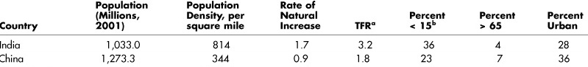

7. Discuss and analyze the reasons for high population growth in South Asia. Include an examination of family planning in your discussion.
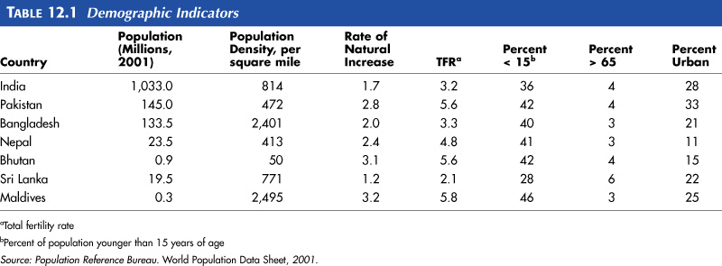

8. Which of the following South Asian cities is believed to become the world’s largest urban agglomeration by 2025?
(a) Calcutta (b) Mumbai (Bombay) (c) Lahore (d) Dhaka

9. Which of the followings has nothing to do with the Punjab region?
(a) Sikhism (b) Rice (c) Breadbasket of India (d) Green Revolution

10. Figure 12.22 (p. 525): Describe the geography of Islam within India. That is, where are the significant Muslim minorities located in India?

11. On what principle was India’s constituent states organized?
(a) religion (b) economic activity (c) political affiliation (d) language

12. [True/False] Hindi or Bengali is more closely related to English than it is to any Dravidian language of southern India, such as Tamil.
** Hindi is the main tongue of the populous states in central northern India, thus the most widely spoken language of South Asia. Bengali is the national language of Bangladesh and the main language of the Indian state of West Bengal.

13. [True/False] In contemporary India, national-level political communication is conducted in Hindi.

14. How has the political geography of South Asia changed in the postcolonial era?

15. Describe geopolitical and ethnic tension in Kashmir, Punjab, and Sri Lanka respectively.

16. [True/False] Upper and central Ganges plain is known for high level of economic development that parallels its position as the traditional population core.

17. [True/False] High-tech industry in India is concentrated in the south.

18. Table 12.3 (p. 545): Which of the following countries has the highest percent of female literacy?
(a) India (b) Pakistan (c) Bangladesh (d) Sri Lanka

