Geog 258: Maps and GIS
February 10, 2006
Exercise: Reading the topographic map in grid coordinate systems

- Determine UTM grid coordinates of Benchmark shown in the upper right.
- What is the elevation in the Benchmark (marked X in the map)?
- From which datum, are horizontal coordinates measured? Does the datum approximate the shape of the earth as a sphere or ellipsoid?
- What is the distance between A and the benchmark (assuming you don’t have a scale bar)? How did you measure it? What is the measurement unit of the distance?

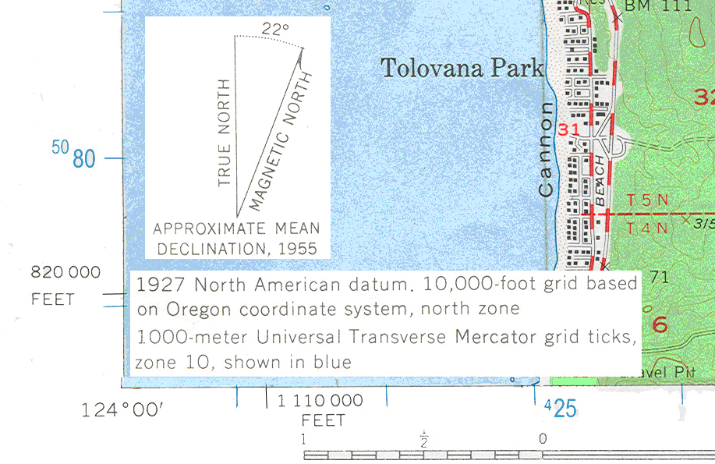
A

