Geography 242: GIS II
Dr. Patrick McHaffie
Office: 990 Fullerton Parkway (Dietzgen Building) suite 4500
Phone: 773.325.7874
Fax: 773.325.4790
Skype: patrick.mchaffie
Email: pmchaffi@depaul.edu
Office Hours: Tuesday and Thursday 9-11am and by appointment.
course website: http://gis.depaul.edu/geography/courses/242/
Lab Assistant: Diana Maties
Class meets Tuesday and Thursday 2.40-4.10 pm in SAC 224.

GIS is a set of related technologies and practices that are concerned with the collection, processing, manipulation, analysis, and display of geographically or spatially referenced data sets. While these kinds of activities have gone on for centuries, principally within the realms of cartography and geography, the development of new technologies over the past few decades has allowed the application of new logics and efficiencies to geographic information processing. This is the second of a three-course sequence directed at the principles of GIS and, through a set of tutorials and lab exercises, builds proficiency in some of the main systems and applications of this dynamic new technology.
One way to think of what we are doing here is deepening our understandings of GIS, but we want to build on the solid framework established in GIS I. In that course we learn that GIS can be thought of in a linear sense as five somewhat linear and linked clusters of operations:
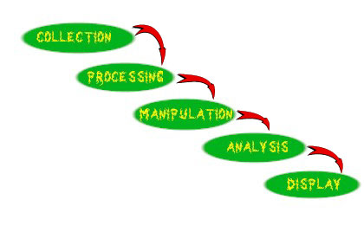
What we want to do here is enrich our understanding of several important topics which are related in some way to one or more of these five, for example some of these topical relationships might be represented in this way:

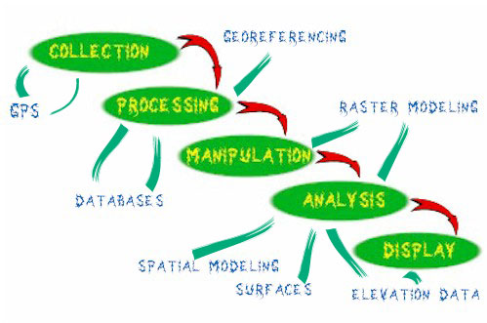
So, in effect what we want to do in refresh our memory of the somewhat loose structure we were presented in the first course on GIS, and while keeping this structure in mind begin to deepen our understanding of several other areas.
Learning Goals
- further develop your proficiency in GIS
- become more adept at scientifically analyzing geospatial datasets
- complete a project working on a real-world problem using GIS tools
Your work will be assessed through a variety of methods:
four lab exercises (10% each)
We will be completing 4 lab exercises using resources in the GIS Lab. Lab exercises will be posted on the class webpage. In some instances you may need to return to the lab to complete work not finished during class time. Lab activities will be graded using a 3-step system with a check - (6), check (8), or check + grade (10). Late work will be assessed fair penalties depending on circumstances. All lab exercises must be completed in order to pass the course. Only the highest quality work will receive the highest grades.
two scheduled quizzes (10% each)
Quizzes may cover any material from the readings, lectures, tutorials, and labs completed prior to date. There will be no "make up" quizzes unless prior arrangements have been made. In the event of excused absence during a quiz period (documented medical or family emergency only) make up quizzes will be completed at the earliest opportunity. Quizzes typically consist of short answer questions, definitions, matching exercises, and/or problem solving exercises.
final project (40%)
Students will develop projects that demonstrate their competence and mastery of particular techniques as appropriate to the particular project. The best of these projects will go outside the University and will service a particular group or institution that has needs in the area of GIS. In this sense we will be engaged in service learning in a very real sense. I have developed relationships with a few different groups who are willing to work with you as you develop your project ideas. If you have other ideas about a project or are interested in doing a project that is independent of particular outside groups or entities contact me at the earliest possibility and we can discuss this. I will have a detailed description of the expectations and requirements for the project early in term.
Attendance and Course Policy
We will normally meet in the GIS Collaboratory in SAC 224. Class attendance is essential to your success. Please contact me as early as possible regarding expected absence from class.
All work completed in this class is expected to be that of the student. Academic Integrity is essential to the life of the university. Violations of academic integrity such as plagiarism will be dealt with under procedures outlined online.
All requirements must be completed in order to pass the course. I encourage students with learning differences to contact me early in the term so that appropriate arrangements may be made for you to complete the course requirements without unnecessary difficulty.
Term Schedule
Date | Topic | Readings
January 5, 7 | Introduction, review and framework | Chrisman Chapter 1, 2
January 12, 14 | Managing GIS Projects: Measurement Frameworks and Representation | Chrisman Chapter 3
January 19, 21 | Attributes and attribute operations | Chrisman 4
January 26, 28 | Elevation and Other Surfaces, Remotely Sensed Data Integrated in GIS | Chrisman 7
February 2, 4 | Raster Modeling  quiz 1 - Feb 4 | Chrisman 5
February 9, 11 | Vector Modeling | Chrisman 6
February 16, 18 | Social/ Political/ Economic Contexts of GeoTechnology | Additional readings will be assigned
February 23, 25 | Final Project Preparation | Additional readings will be assigned
March 2, 4 | Scheduled meetings with Project Groups | Additional readings will be assigned
March 9, 11 | Summary, Final Project Preparation  quiz 2 - Mar 9
Tuesday, March 16, 2010, 2.45pm | Final Project Presentation
Reading assignments are to be completed by the end of the week indicated.
Final Project Milestones
- Choose/ Propose Final Project (January 12)
- Needs Analysis/ Literature Review (January 26)
- Plan to Translate Needs/ Requirements into Tangibles (February 9)
- Data Summary and Discussion of its Utility (February 23)
- Conduct Data Analysis and Design Maps (March 9)
- Presentation of Project/ Submit Final Report (March 16 – 2.45pm)
Clients will attend final presentation.
Potential Projects (not a complete list)
Asian American Institute (AAI)
AAI are beginning work on the question of legislative redistricting in the Chicago region. They are interested in creating a number of maps that will support their work on redistricting – these will likely be created using the census data and the American Community Survey updates to Census 2000.
Egan Urban Center (EUC)
The EUC are engaged in putting together a comprehensive community profile for Chicago Area Project in the South Chicago community. They are particularly interested in building capacity for community based organizations that work with youth in their community.
Puerto Rican Cultural Center (PRCC)
The PRCC is interested in beginning explorations for community mapping in their community – principally in the Humboldt Park community area. They are particularly interested in creating community mapping that is sustainable and that can be updated by members of the community after our work has been completed.

