Geography 242 – GIS II  
Activity 1

This activity will get you into a couple of areas while getting familiar with a Chicago dataset that should prove useful to all. You may work in groups of two on this activity. The dataset that was distributed in class has a number of layers that will be useful as a base set for your work with Chicago-area community organizations. The layers look something like this in ArcCatalog:

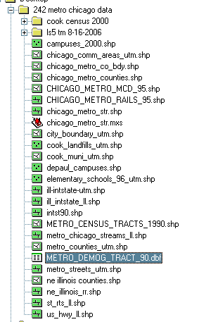

Inside the cook census 2000 folder there are some other resources:

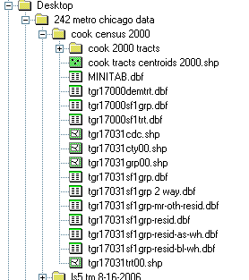

There is also a satellite image and DEM folder:

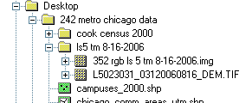

All of these data have been georeferenced in some way – generally either using decimal degrees (WGS 84) or UTM zone 16N. Explore this folder and get familiar with it. This is one of a few data dumps you’ll be getting this term. This activity comes in two parts:

Part 1 – Use the data in the folder to create a single C-size map of the city of Chicago or Cook County showing at least one (1) raster layer and at least five (5) vector layers. Your maps should be stunning – they should include N-arrow, graphic (bar) scale, legend, title, and a small text box with your name (lower right corner, no-larger-than 10-pt font).

Part 2 – The Commuting City: For this part you should use the 2000 census tract layer named **fe_2007_17031_tract00** found here:

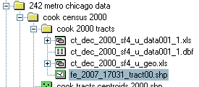

and the dbf table titled **ct_dec_2000_sf4_u_data001_1.dbf** (this is commuting data from the SF4 files for Cook County – the SF4 documentation is [here](http://www.census.gov/prod/cen2000/doc/sf4.pdf)). The table can be joined to the shapefile using the field **CTIDFP00** in the shapefile as the destination and the field named **JOINFIELD** in the dbf table as the source. After joining these data answer the following questions in clear English:

1. In how many census tracts were there more than 1000 people car pooling? Describe this geography.
2. In how many census tracts were there more than 500 people car pooling or more than 500 people riding a bike? Describe this geography.
3. In how many census tracts were there less than 50 people car pooling? Describe this geography.
4. In how many census tracts were there less than 50 people car pooling and less than 50 people riding a bike and more than 1000 people driving alone? Describe this geography.
5. In how many census tracts were there more than 200 people walking? Describe this geography.

Use all the resources at hand to answer these questions in a thoughtful way. Turn both parts in – the first as a C-size map printed on the Designjet, the second as a typed document. Due January 19 at the start of class.