Geography 242 – GIS II
Activity 2
This activity will get you into a couple of areas while working with a Chicago dataset that should prove interesting to all. You may work in groups of two on this activity. In this activity work with the data in the “242 metro chicago data” folder that you received earlier in term. In particular these layers will be used:
- cook_landfills_utm (this is from 1997, so it is very coincident with the layer below)
- elementary_schools_96_utm
- tgr17031grp00 (this can be joined with tgr17031sf1grp – close to these two above in time – year 2000)
There may be other useful layers in your folder as well – don’t limit yourself to just these two.
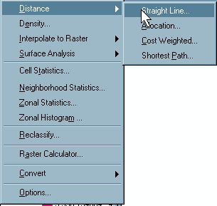
The analytical skill we are going to work on here is a fundamental (and quite useful) technique (or set of techniques) in GIS – namely investigating the relationships between two (or even more) layers in a particular place and time.
Starting Out
Begin by opening these three layers in ArcMap. Perform a Distance analysis of the landfill layer using Spatial Analyst:

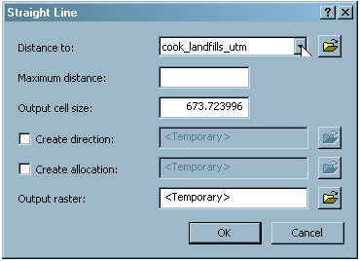
Make sure to set the values to something that makes sense, something like this (since I’m using the UTM as the coordinate system in this landfill layer, distances and areas are in meters and square kilometers).
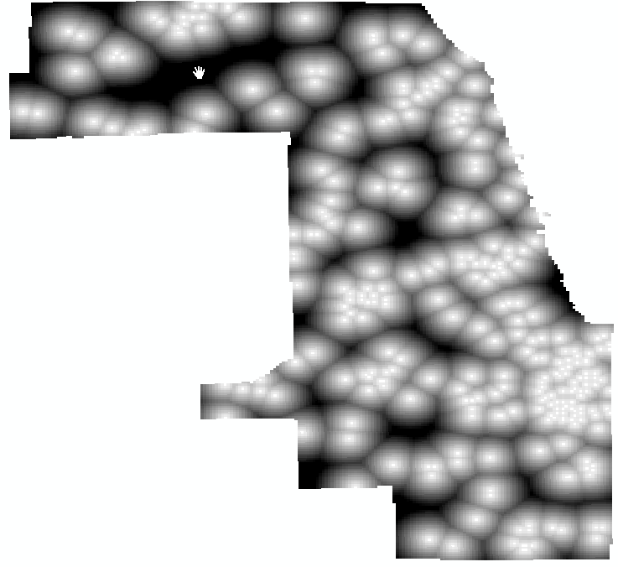

After the analysis your map could look something like this:
In this raster layer the light areas are close to landfills and the dark areas are further away. Exploring this layer with the information tool you should find that distances are in meters.

Making the Connection
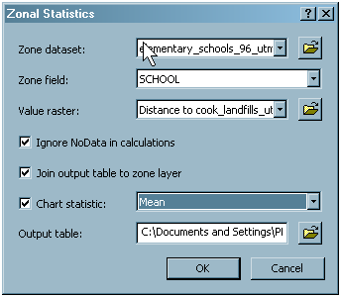
Next I want you to use the Zonal Statistics module in Spatial Analyst to create a zonal statistics table for the Elementary Schools layer – this will analyze the raster distance surface to create a table for this layer that contains the distance of each school to the nearest landfill. The zone dataset is the vector layer you want to use as the target, the zone field needs to be a unique field in the table, and the value raster is the distance surface:

You can choose to join the new table to the attribute table of the zonal field, as I have here. Take a good, close look at the help topic “Zonal Statistics Tool/Command” in ArcGIS help for a detailed discussion of the workings of this function.

By Joining this table to the attribute table of the schools layer, we can map schools now based on an environmental variable that we have created – distance to landfills – low values can be thought of as “bad” in some ways while high values can be thought of as “good” in others.
A Next Step
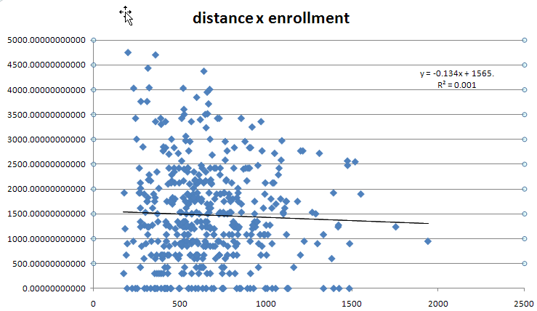
Now that we’ve done this (especially the joining the tables part) we can export the attribute table for schools as a “dbf” table. This can be used in any of a number of applications (e.g. Excel, Minitab, SPSS) to further analyze the data. For instance, here is a scatterplot of distance vs enrollment with the equation and correlation coefficient on the chart (from Excel).

Now, what else can you do? Try using the census layer as the zone field, with the distance layer as the value raster. When you’ve completed a similar analysis to that above, make a detailed map/ graphic of this model using all available tools. Print this in C-size with rich marginalia (i.e. explain what this is, how you did it, and use all available tools/data to make a rich graphic).
Use all the resources at hand. Turn your map/graphic in to signify completion of the . Due February 11 at the end of class.

