Geography 242 – GIS II
Activity 3
This activity is presented as a challenge. In Chapter 7 of the Chrisman book he discusses “surfaces” - called in some places Z-surfaces (recognizing they are often expressed as values on the z-axis of a 3-d Cartesian system). This is as rich a discussion of surface modeling as you’ll find in an intermediate-level text. Refer to the handout I gave you about this chapter. In your Grades Online account I’ve placed a link to a zipped dataset for Cook County. These data are associated with the locations of Toxic Release Inventory (TRI) sites for calendar year 2006. The important fields in the attribute table are here:
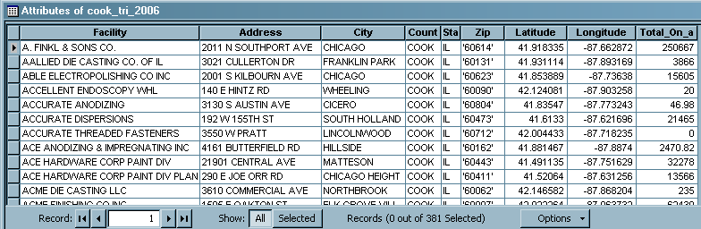
The last field (Total_On_a) is the total poundage disposed of a list of tracked substances on- and off-site in 2006 by the facility – this will be the subject for our challenge.
I want you to interpolate a scalar surface for this attribute using any of the three interpolation routines in Spatial Analyst – you may or may not want (or be able) to clip this surface to the Cook County shape included with your dataset.
Then I want you to calculate a secondary raster layer from one of the tools available to you in Spatial Analyst. The surface that you calculate should be related to one of the 20-odd topics in Chapter 7.
Print a brilliant C-size map of your first interpolation surface (don’t forget ArcScene)  using all resources at hand (try to keep from making your map too busy, and make certain to explain clearly what you’ve mapped and how in the margins). Answer the following questions on a separate sheet.
- What interpolation routine did you use? Briefly explain how it works.
- How did you calculate the secondary raster layer – what topic in Chapter 7 of Chrisman is it related to?
Print your layout (C-size) and the answer to these questions and hand them in at the end of class, March 4. Aces.

