Section: |  |  |  | Name:

Geog 258: Lab Assignment 5

Map Projections

A map projection is a mathematical transformation of all the points on a globe to their respective points on a flat (planar) map. Every flat map misrepresents the surface of the earth in at least one way. Each map embodies a number of choices and compromises. Many different solutions have been developed over the years, each one designed to solve a particular problem or to result in a map that is useful for a particular purpose. (See attached notes page.)

A. General Classification of Maps by Geometric Properties

In Lecture, you learned of 4 general classifications for maps based on their geometric properties: conformal, equal area, equidistant, and azimuthal. (“Geometric properties” simply means what kinds of properties the features of the projected map take on.) Since no projection preserves all of the geographic information contained on a globe, the map maker must make fundamental decisions about what to preserve and what to sacrifice. Consequently, maps in each of these classifications are more suitable for certain kinds of tasks. For the two classifications below, discuss among yourselves to determine what each of these kinds of maps preserves (and what it sacrifices), what it is useful for, and why.

Geometric Properties | Preserves (and sacrifices) | What it is useful for… and why?
Conformal
Equal Area

Open your computer browser and go to http://www.btinternet.com/~se16/js/mapproj.htm. This website has an interactive world map that lets you choose among various projections. Note particularly the difference between the Mercator projection (which preserves direction) and any of the several equal area projections. Which is your “favorite” projection and why?

Now open ArcMap software. (Either double click on the desktop icon, or from the START menu, choose All Programs→ArcGIS→ArcMAP. Open the map:

P:\geog258win06\Lab 5 data\World map NAmer equal area conic.mxd

Open a second copy of ArcMap. In this window, open the map:

P:\geog258win06\Lab 5 data\World map NAmer conformal conic.mxd

Click back and forth between these two maps. Note the different shapes and sizes of the continents. Note that these are both conic projections.

On what parts of the maps are the differences most noticeable? Least noticeable? Why?

What form of distortion is each map minimizing?

- Equal area conic:

- Conformal conic:

B. Projection Families Fill in the following table.

Projection Family | Draw a sketch | Where is minimum distortion?  (Is it a point, line, circle?) | Where is maximum distortion?  (Is it a point, line, circle?)
Planar
- Tangent
- Secant
Cylindrical
- Tangent
- Secant
Conic
- Tangent
- Secant

A map-maker must choose which projection to use based on the particular application for which the map will be used. An important determinant is where the area to be mapped falls in relation to the distortion pattern of any projection. One "traditional" rule described by Maling (1992) says:
- A country in the tropics asks for a cylindrical projection.
- A country in the temperate zone asks for a conical projection.
- A polar area asks for an azimuthal projection.
Explain why each of these is a good choice of projection for that particular part of the globe. (Hint: where is the least distortion in each of these types of projection?)

C: The Graticule

Define graticule: ________________________________________________

Graticules look different on maps with different projections. Looking at the graticule on a flat map and comparing it to what you would expect it to look like on a globe will give you a good idea of the areas of the map that show the most (and least) distortion.

Look at the four maps below. Try to identify which projection family (planar, cylindrical, conic, transverse cylindrical) each belongs to based on how their respective graticules are drawn.

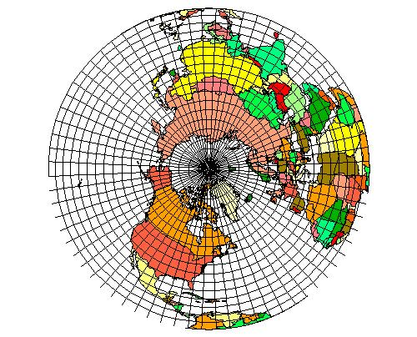 |  | 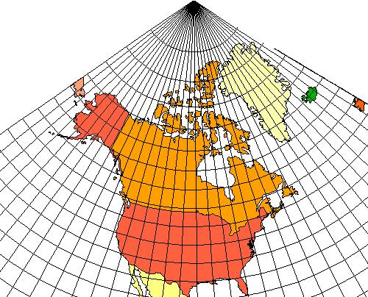
1. |  | 2.
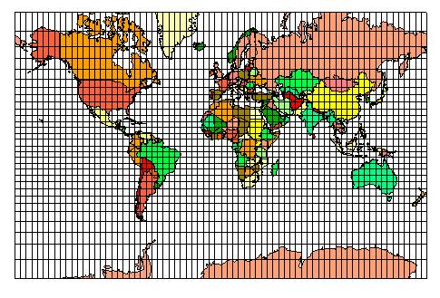 |  | 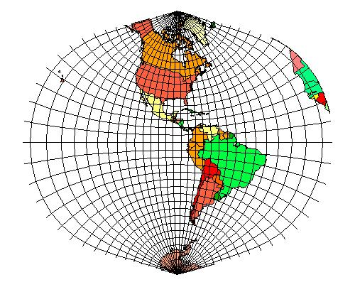
3. |  | 4.

Looking at the two world maps on the next page, note that both are cylindrical projections. Which map would you say is the most “accurate?” Why?

Both of the maps below have standard parallels at 45 degrees. Start by finding the equator and highlighting it with a pencil or pen. Next, locate and highlight the standard parallels on each map. Label the equator and the standard parallels with their respective latitudes. (Hint: Use your own general knowledge of world geography. What is the latitude of the border between the continental US and Canada? Don’t forget there are two standard parallels on each map, i.e., these are secant cylindrical projections. How do I know that?)

Now that you have highlighted the standard parallels, compare some obvious features on or near those parallels in one map with the same features in the other. Also compare features along or near the equator. Are the features near the standard parallels or those near the equators more similar in shape and size? Why is that?

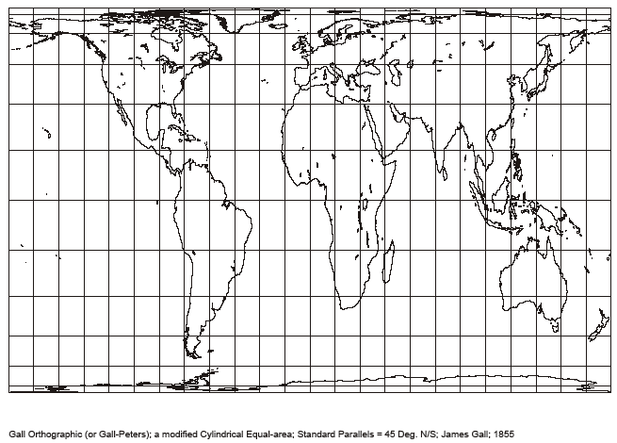

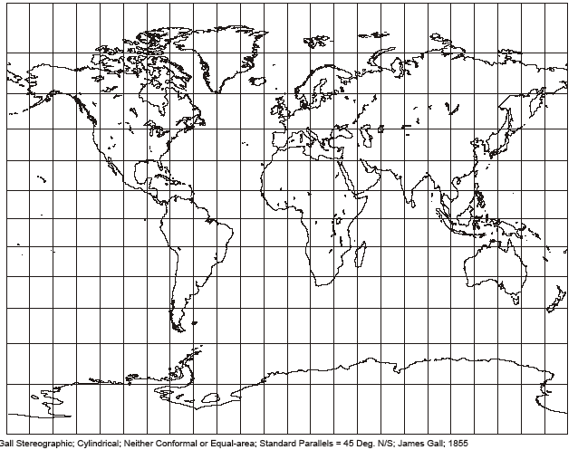

Study questions (Do not turn in)

Types of Distortion

Be low is a list (taken from page 46 of your textbook) of 7 forms of distortion created by projecting a globe onto a flat map. For each, give a short definition or description of what it means.

Form of distortion | Definition or Description
Continuity
Distance
Area
Direction
Shape
Completeness
Preserves correspondence relations

from hosting.soonet.ca/eliris/ gpsgis/Lec2Geodesy.html

Map Projections
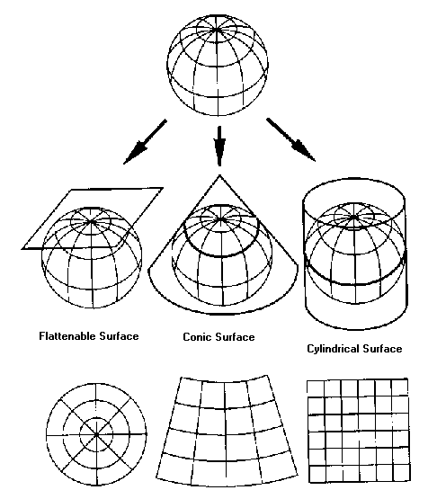
Map projections are representations of a sphere (the Earth) in two dimensions. A mathematical transformation is required in order to convert Latitude & Longitude coordinates into Cartesian Coordinates on a two dimensional surface. This transformation results in distortions of the original three dimensional surface in two dimensional maps.
Map Distortion
Distortions result in changes to the shape, size, area, and direction on a map.
Conformal Projections are characterized by shape retention (i.e. Lambert Conformal Conic). So that a small circle on globe will remain a circle on the projection, but the scale or size may be different.
Equal Area (or Equivalent) Projections are characterized by area retention (Albers Equal Area Conic). So if South America is eight times larger than Greenland on the globe, it will also be eight times larger in the projection.

