Section: |  |  |  | Name:

Geog 258: Lab Assignment 6

Thematic Maps

I. Identifying Thematic Maps

Thematic maps are often categorized by the type of symbols used to convey information (or the theme of the map). Some common types of thematic maps are:

- Proportionate symbol maps  - Choropleth maps  - cartograpms | - Dot maps  - Isoline maps  - Daysymetric maps

Which type of symbolization is used for a given map depends on several variables, but the most important are the kind of data used and displayed (including the level of measurement) and the purpose for which the map was created.

The power of thematic maps is that they portray specific data in geographic locations in compelling manner. These geographic locations may be physical locations or representative locations.

For each of the maps on the following pages, fill in the information requested.

World Bank Map of GNP
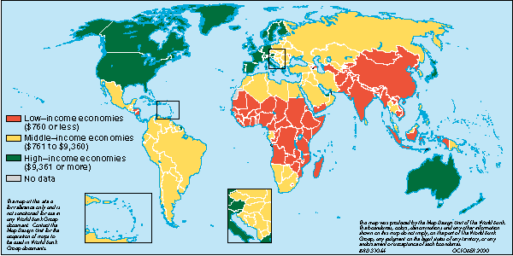
- Type of thematic map:
- Level of measurement of the data:
- Number of data classifications:
- Are locations physical or representative?
- What spatial units are used to organize the data?
- Why did the mapmaker choose these spatial units?
- What other spatial units might he/she have chosen to use?

African Immigrants as Percentage of HIV/AIDS Cases in Europe
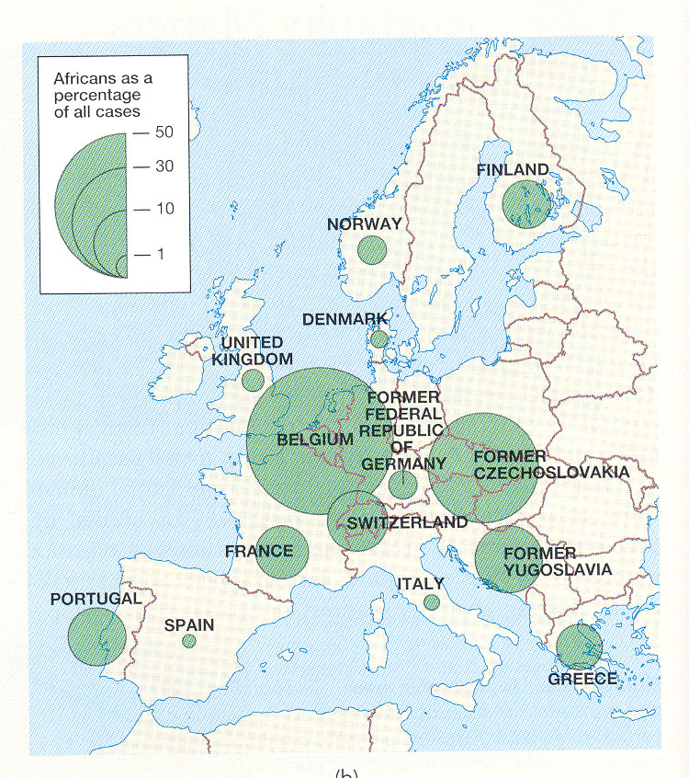
- Type of thematic map:
- Level of measurement of the data:
- Number of data classifications:
- Are locations physical or representative?
- What spatial units are used to organize the data?
- Why did the mapmaker choose these spatial units?
- What other spatial units might he/she have chosen to use?

Acres of Vegetables Harvested in the U.S.
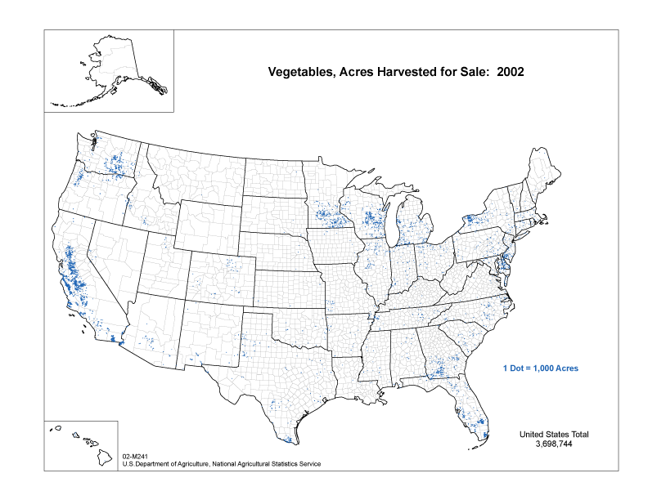
- Type of thematic map:
- Level of measurement of the data:
- Number of data classifications:
- Are locations physical or representative?
- What spatial units are used to organize the data?
- Why did the mapmaker choose these spatial units?
- What other spatial units might he/she have chosen to use?

World Cargo Transportation
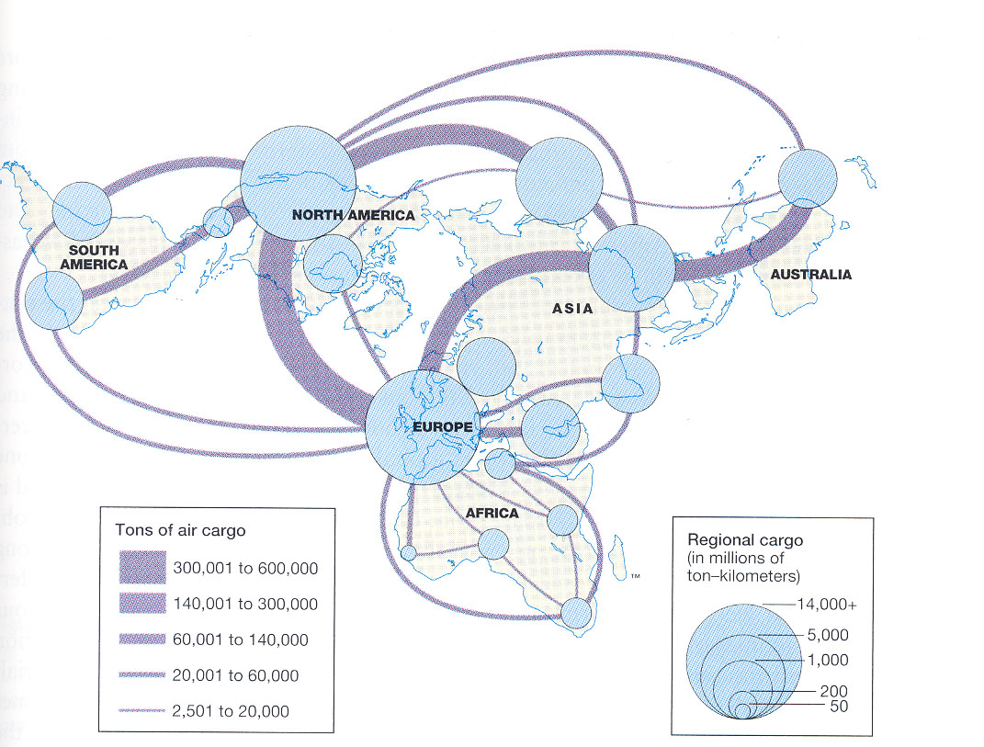
- Type of thematic map:
- Level of measurement of the data: | a)
 | b)
- Number of data classifications: | a) b)
- Are locations physical or representative? | a) b)
- What spatial units are used to organize the data? | a)
 | b)
- Why did the mapmaker choose these spatial units?
- What other spatial units might he/she have chosen to use? | a) b)

Electoral College, 2004 Presidential Election
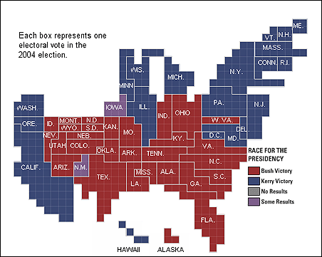
- Type of thematic map:
- Level of measurement of the data: | a)
 | b)
- Number of data classifications: | a) b)
- Are locations physical or representative? | a) b)
- What spatial units are used to organize the data? | a)
 | b)
- Why did the mapmaker choose these spatial units?
- What other spatial units might he/she have chosen to use? | a) b)

II. Interactive Thematic Maps

Thematic maps lend themselves to computer generation. They are also fun to use and informative and therefore have become popular as interactive tools on the World Wide Web. In this section you will look at a couple different web-based interactive maps. The objective of this exercise is to look at these with a critical eye, evaluating their cartography and usefulness.

a. Demographic Data Viewer (CIESIN) http://plue.sedac.ciesin.org/plue/ddviewer
From the home page, choose the newest (Java) version of the software. First, select geography either choosing a small number of states, or zoom in to one state and choose specific counties. Second, choose a small number of variables to map. Finally chose “Submit Job.” You can see the mapping of the different variables by choosing them in the window on the right.
Now, choose “Customize Map.” Note that this tool lets you change the classifications from quantiles to equal intervals, and lets you choose how many classifications your map will have. Spend some time trying different variables and different data classifications.
1. What geographic area? ________________
2. What variables: ________________________________________________
3. What is the difference in the maps’ appearance between quantiles and equal intervals?

4. How different is the “message” (what the map tells you) when you look at the data at the county level instead of the state level?

b) National Atlas http://www.nationalatlas.gov/
Click on “Map Maker.” Try some maps by choosing a geographic area, then selecting layers frm the right-hand column. (Once you have selected the layers you want, click on “Redraw Map” at the top of that column.) Be sure to check out the “Map Key” tab (at the top of the right-hand column). Try the Identify button above the main map widow.
5. What do you think about the selection of variables? To whom might they be useful?

6. Can you tell what kind of classification method they are using?(are they telling you?)

c) Comparing these two sites:

Which one of these sites provides the better data? (Explain your answer.)

Which one of these sites provides the better cartography? (Explain your answer.)

Which one of these sites provides the better interface? (Why do you like it better?)

