Geog 258: Lab Assignment 7
Section: |  |  |  | Name:

Introduction to GIS

A GIS organizes and stores information about the world as a collection of thematic layers that can be linked by geography. Each layer contains features having similar attributes, like streets or cities, that are located within the same geographic extent. This simple but extremely powerful and versatile concept has proven invaluable for solving many real-world problems--from tracking delivery vehicles, to recording details of planning applications, to modeling global atmospheric circulation. (ESRI Virtual Campus website)
- GIS Data – Representing the Real World
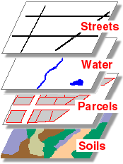
A. GIS systems use the concept of “layers” to allow the mapmaker to add and manipulate many different kinds of geographic information. You can visualize this layering by imagining drawing several separate maps of the same area on clear plastic, each showing different features that occur in that area, and then laying the maps on top of one another.
These four layers might be part of one city's geographic dataset. The layers all contain features located within the city's boundaries, but each one represents a distinct "theme." (Source: http://campus.esri.com)
B. In its simplest form, a GIS typically stores two very different kinds of data for each of these layers: location data and attribute data. Both are vital to the representation of phenomena on maps.
- Location data
Location data is usually the first thing we think about when we think about a GIS. Location data tells us where particular features are. Again in its simplest form, a GIS deals with three basic kinds of location data, represented by three specific geometries:
- Point data describe things that happen at one specific point on the map. An example might be an air temperature measurement or the location of a parking meter. On a small scale map, cities might be represented as points.
- Line data describe features such as roads and streams – features that have a beginning and end point, but no width.
- Polygon data describe areas. State boundaries, land parcels, and building footprints are examples of features that may be represented by polygons. On medium and large scale maps, roads, rivers and cities may be represented using polygon geometry.
- Attribute data
Attribute data is fundamentally different from location data, but is linked to and dependent on location data. Attribute data describes what is at a given place. It is stored in tables linked to the location data.
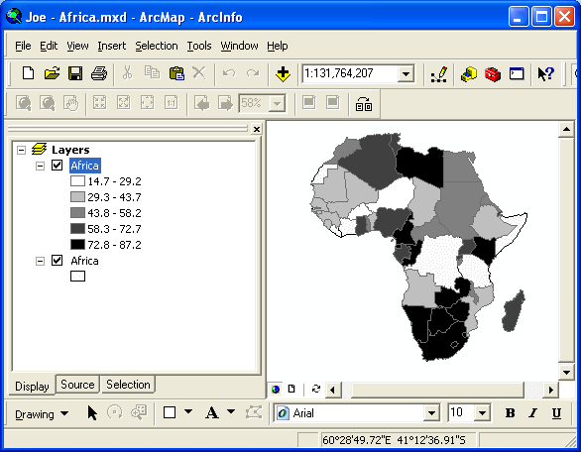
For example, if you have data about the population of a state by county, the county boundaries – location data stored as polygons, i.e., the where component of the data – will be linked to a table that lists the population numbers for each county. This link directly associates the specific map locations with the attributes (the data about the phenomena) that occurs at those locations.
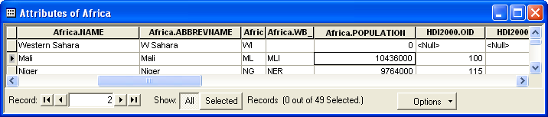
In this example, each country in Africa (right) has a corresponding line in the attribute table (below) that includes (among other data items) the country’s name and population for the year 2000.
- Exploring Bainbridge Island Data
Open ArcMap from the Start menu: START→ ArcGIS→ArcMap
Browse for an “existing map” and open:
P:\geog258win06\Lab 7 data\Lab 7 Bainbridge Island.mxd
The map image you see is a simple outline of Bainbridge Island, WA. Notice in the table of contents for this map (on the left) there are 6 different layers of mapping data besides the shore outline. Take a few minutes to turn these layers on and off (by checking and unchecking the corresponding check-boxes) to get an idea of the various kinds of data available to you.
Note: By combining these layers in different ways, changing mapping symbols and/or colors, zooming in or out, etc., you could potentially make thousands of different maps from this data set!!
- First let’s examine the location aspects of this data – the where component. By turning on the layers in this map one at a time and examining the visual representation of that data, fill in the following table about the geometry (point, line, or polygon) of each layer. (Hint: zooming in can help.)
Layer Name | Geometry |  | Layer Name | Geometry

Even though each layer’s data is stored as a specific geometry and cannot be changed (without certain very specific and technical transformations), the symbols used to represent the locations and geometries of the data can be easily changed by the mapmaker using a computerized GIS.
Click once on the red line symbol underneath the “streams” layer. This will bring up the “Symbol Selector” window for that layer. Note that all the symbols in the list at the left of this window are different kinds of lines. You can choose a new symbol from this list, or you can customize the symbol by choosing a color and a line width from the right side of the “Symbol Selector” window. Pick a more appropriate symbol for the streams layer and press “OK.” (Remember, you can always go back and change it later, so have fun experimenting!) Record your new symbol here (either a symbol name or a “color/width” description):

Choose new symbols for the “streets,” “schools” and “wetlands” layers and record your choices. Note that you have different options depending on the geometry of the data!
New “streets” symbol | New “schools” symbol | New “wetlands” symbol

- Now we’ll look at the attribute data for these layers. To start with we will query specific features using the “identify” tool.
- Turn off all the layers (by unchecking their respective boxes) except the “shore outline” and “schools” layers. Choose the “identify tool” (looks like a blue circle with the letter “i” in the middle). One by one, click on each point on the map that represents a school. The identify window will show you all the attribute data (the what data) for that school. Record the name and the fictitious population (“fict_pop” – fictitious because I added made up numbers to the data set for the purposes of this exercise) for each school below. (Zooming in may make this easier.)
School Name | Population |  | School Name | Population

When you are done, choose the pointer tool (black arrow) from the toolbar and close the information window.
- Another way to view the attribute data for a layer is to look at the entire attribute table at once. Right click on the “schools” layer in the table of contents and choose “Open attribute table” from the menu. This shows you all the associated data in tabular form. Close this window when you are done. Feel free to look at the attribute tables of the other layers as well.
- Now we’ll change the “schools” symbol to reflect the attribute data. (This is the fundamental step in making any thematic map.) In this example we will make a proportional symbol for each school based on its (fictitious) population.
Double click the “schools” layer in the table of contents. In the resulting window, choose the “symbology” tab. In the left-most column, choose “Quantities” then choose “Proportionate Symbols.” In the “Fields – Values” field, choose “fict_pop.” Now click on the “Min value” button, bringing up the “Symbol Selector” window. In this window, search through the list and choose the “School 1” symbol (or any other symbol that you like). Press “OK” to leave this window, and “OK” again to get back to your map. You can see now that the schools are symbolized with both their location and their population. Print this map and turn it in with your assignment. (Only print one copy and put all group members’ names on it, please.)
- Now let’s do some simple proximity analysis.
  - First we’ll use simple “visual inspection.” Turn on the “wetlands” layer. Zoom in to the schools symbols and identify which schools appear to be “close” to wetlands. (You can define “close” for yourselves.)
  - Now we’ll do the same thing, letting the computer do some of the work. On ArcMap’s main menu, choose “Selection” then “Select by location.” The first box should read “select features from.” Check “schools” in the list, indicating we want to find those schools that meet our criteria. Set the next field to “are within a certain distance of” and in the following field choose “wetlands.” Finally, where it asks you to define a buffer, type in “400” and choose “feet.” We have just asked the computer to find all the schools that are within 400 feet of a wetland area. Press “Apply.” Use the “identify” tool to query the selected locations and write in the names of these schools here:

When you are done, close the identify and select windows. From the “Selection” menu, choose “Clear Selected Features.”
  - Turn off the “wetlands” layer and turn on the “geohazards” layer. (This layer combines data about several kinds of hazards but is predominately about landslides.) Now use the same technique from above to find all the schools that are within a quarter mile of a geohazard area. List those schools here:

  - Now turn off the schools layer and turn on the streets layer. Using the “Select by Location” tool (as above), select all the streets that intersect “geohazard” areas. Close the “Select by location” window. Now right click on the “streets” layer, choose “Selection” and choose “Create layer from selected features.” Notice that a new layer has now been added to your map. Change name of this layer (by slowly clicking twice on its label in the Table of Contents) to “vulnerable streets.” Now resymbolize this layer so the vulnerable streets stand out easily (e.g., bright yellow lines, width 3.00.) “Clear selected features” from the “Selection” menu. Question: who might find this map useful?

  - If you have time, play around with the “landcover” layer. For instance, you may want to ask, “What kind of landcover is associated with the different schools?” or “Where is most of the urban and residential land?” or “Is there a correlation between forested land and wetlands?” Come up with some of your own questions to explore.

